CURRICULUM VITAE
Name: SANGHITA PAL  Date of Birth: June 18th 1968  Husband’s Name: Dr. Sanjoy Kumar Pal | 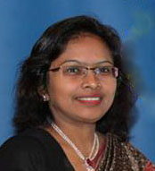
Address for Correspondence: Flat No. 603; Building No 32
Sanskruti (Building No.: 31 - 34)
Co-operative Housing Soc Ltd.
Thakur Complex, Kandivali East
90 feet Road, Mumbai – 400101

Email: sanghitapaljune@gmail.com

Phone: 09930035025 (Cell)

Languages known: English, Hindi & Bengali

Educational qualifications:
----------------------------------------------------------------------------------------------------------------------------------
H.Sc. 1989 Council of Higher Education, West Bengal

B.A. 1992 University of Calcutta

Sr. Diploma (Music) 1995 Pracheen Kala Kendra Chandigarh

Sr. Diploma (Guitar) 1983 Part I Pracheen Kala Kendra Chandigarh

Special Training:

- Attended one-day workshop on ‘Innovative method of teaching’, conducted by Oxford University Press, at Ryan International School (ICSC), Malad, Mumbai on June 2008.

- Attended one-day Workshop on New Approaches to English Language Teaching conducted by Orient Longman Private Ltd, at Hotel Madhuban, Dehradun on November 17, 2007.

- Abacus Training (Level I & II) from Master Franchisee of UCMAS Mental Arithmetic India Pvt. Ltd., Lucknow.

- Participated in the ‘Global Trends and Innovation in Education,’ held in City Montessori School, LDA branch, Kanpur Road, Lucknow, December 2006.

- Montessori Training from Calcutta Montessori Training Centre, Pratt Memorial School
Kolkata.

- ‘TOEFL’ coaching from YMCA English language and TOEFL Coaching Institute.

- Senior First Aid Course from St. John Ambulance Association, Kolkata.

Experiences:

- Working as assistant teacher (Secondary Section) in Ryan International School (C.B.S.C.), Kandivali East, Mumbai from August 2008.
- Worked as teacher (Primary section) in Brooklyn School, Dehradun from May to July 2008.
- Worked as teacher (Primary section) in Sherwood School, Dehradun from July 2007 to April 2008.
- Worked as assistant teacher (Primary section) in City Montessori School, LDA branch, Kanpur Road, Lucknow from 2004 to 2007.
- Primary school teacher in Colonel’s Academy, Lucknow from 2003 – 2004.
- Worked as Primary school Teacher in Ideal High Secondary School, Bhopal from 1996 – 1998.
- Worked as Teacher in Athena Public School (English Medium) Kharagpur from 1992-1994.

Awards:

Awarded ‘International School Award,’ by the British Council for the school project (Ryan International School) on December 2014, function held at New Delhi.

Awarded ‘International School Award,’ by the British Council for the school project (Ryan International School) on December 2010, function held at Chennai.

Sports:

Participated in various swimming events.

Other Activities:

Represented Ryan International School (C.B.S.C.), Kandivali in DAIMUN 2009 at Dhirubhai Ambani International School, Mumbai on 19 – 20 December 2009.
Editor of the news letter ‘Rhapsody’ published from Ryan International School (C.B.S.C.), Kandivali, Mumbai 2009 - 10.

Was the anchor in the Mumbai International Children Film Festival held at St. Lawrence School. Kandivali held from 6th Nov to 12th Nov 2009.

Coordinator of International School Awards from Ryan CBSE in collaboration with British Council.

Acted in ‘HM 26/11 Mumbai Under Attack, a movie based on the Mumbai terror attack 2008.

Participated and presented various educational and popular programs in the CMS FM Radio (90.4 MHz).

Participated and coordinated the function of the 8th International Convention on Students’ quality control circles 2005, held in CMS, LDA branch from 2nd – 5th December 2005.

Participated and played an active role in the Saraswati Puja cultural function held in the Sanjay Gandhi Postgraduate Institute of Medical Sciences (SGPGIMS), Lucknow.

Participated and coordinated the function of the Annual Day Celebration of the B H E Zakir Hussain Model Middle School, Piplani, Bhopal.

Family:

I am married and have one daughter. She is studying in class X at Ryan International School, Kandivali East, Mumbai. My husband Dr. Sanjoy Kumar Pal is has just returned from Ethiopia, he was Assistant Professor in Haramaya University, Dire Dawa for the last 4 years. My father Mr. Brojen Das was a legendary sports personality. He was the first Asian to cross the ‘English Channel.’ He was awarded the title ‘King of Channel’ in 1968 for crossing the channel 6 times with 2 world records (www.brojendas.com). My mother is a renowned classical singer and TV artist. My father-in-law Dr. D. N. Pal is a dermatologist; he retired as D.M.O. from South Eastern Railway Hospital, Kharagpur. One of my brothers-in-law, Dr. Sumit Kar is Professor and head, Department of Dermatology, Mahatma Gandhi Institute of Medical Sciences, Sewagram and the other (Sandip Pal) is a software expert and manages his own Computer Firm ‘ Net Campus’ in STEP, Indian Institute of Technology, Kharagpur.

References:

Mrs. Anjali Bowen
Head Mistress
Ryan International School
Kandivali East
Mumbai
Tel: 09892105902

Mr. Kavita Dev Mukherjee
Zee Learn Limited
Level 6, Fun Republic
Off. New Link Road
Andheri (West)
Mumbai - 400053
Tel: 09619127207

Mrs. Mala Yadav
Head Mistress
City Montessori School
LDA Branch
Kanpur Road
Lucknow (UP)
Phone: 0522 2435690

Other information:

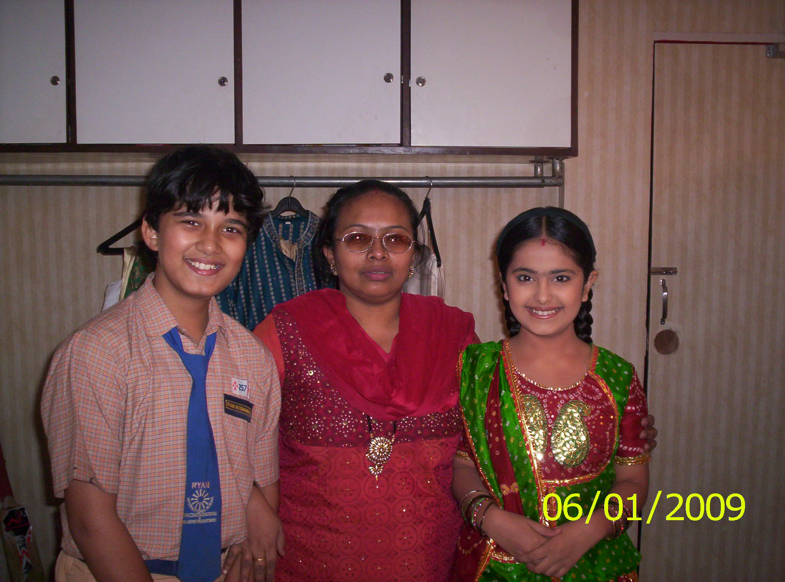
I give private tuition to two very renowned TV child artists Avinash Mukherjee and Avika Gor. Both of them are lead actors of the serial ‘Balika Badhu’ of Colours.

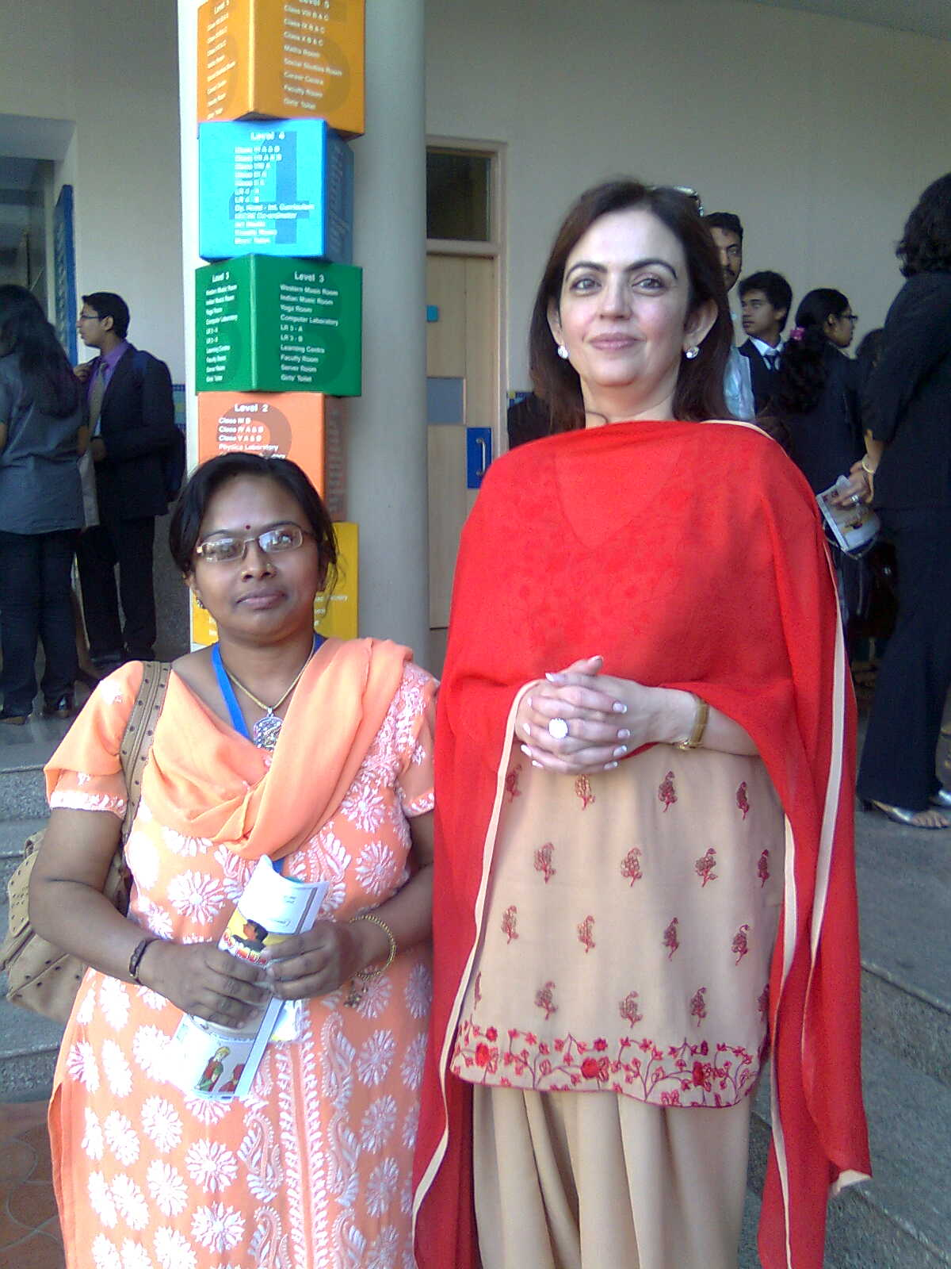
I had a chance to meet Madam Neeta Ambani during DAIMUN 2009.

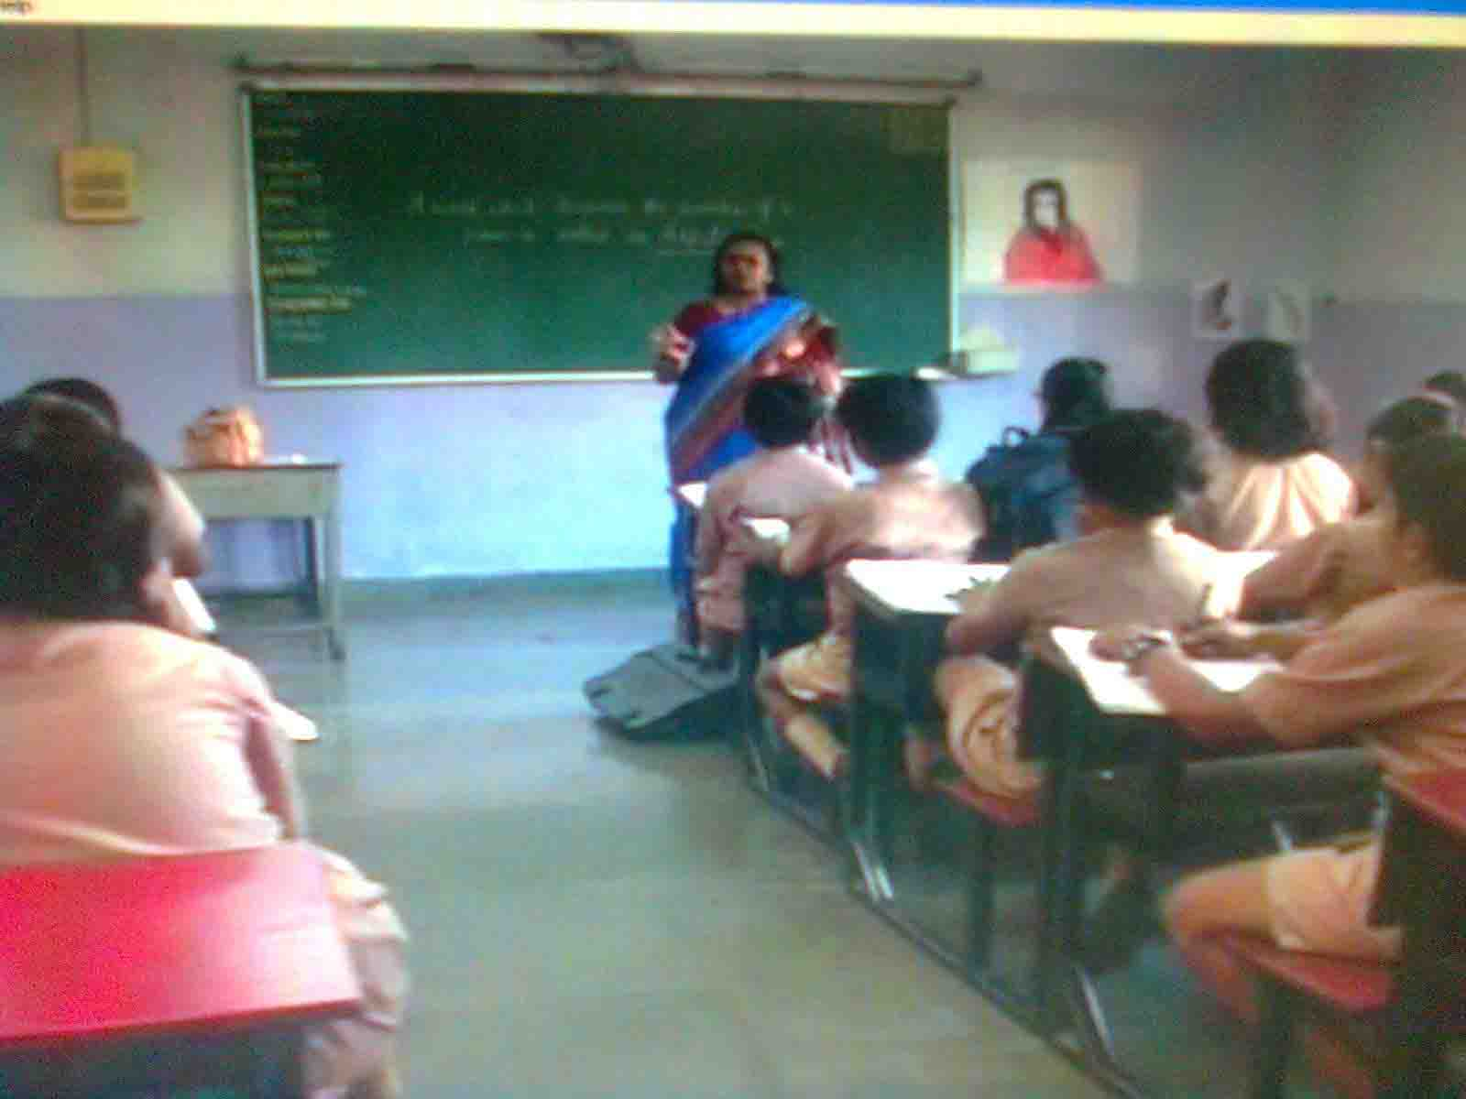
A scean from MH 26/11 where I acted as an English teacher

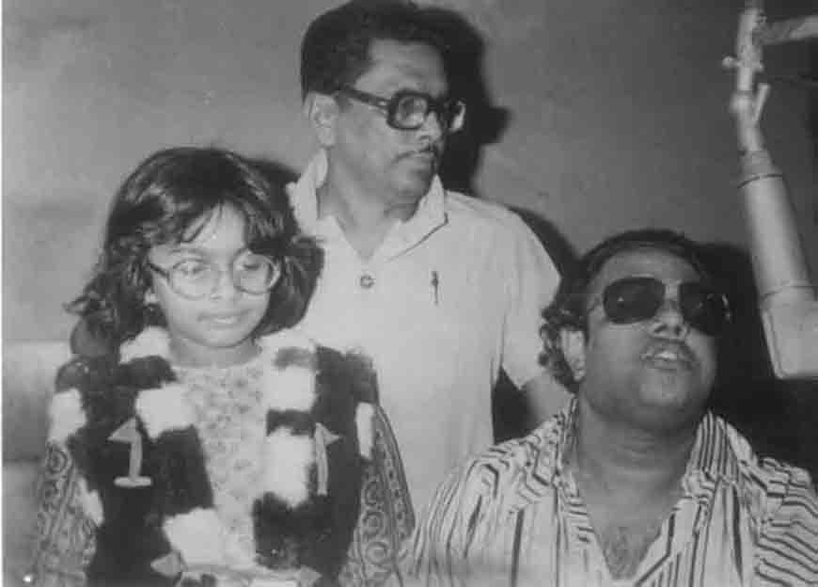
I got my first music lesson from Shri Ravindra Jain

